St. Mira's College for Girls
Self Study Report Submitted to NAAC, Bangalore
For Assessment and Accreditation
Cycle 3
Annexures
Track ID No MHCOGN10195

ST. MIRA’S COLLEGE FOR GIRLS, PUNE
TABLE OF CONTENTS
 | Particulars | Page No.
1. | NAAC Steering Committee | 03
2. | Preface | 04
3. | Principal’s Message | 05
4. | Executive Summary and SWOC of the Institution | 06
5. | Approval of Courses by Affiliating University | 14
6. | UGC recognition under section 2(f) and 12 (B) of UGC Act | 15
7.a | List of Departments | 17
7.b | List of Subjects – Syllabus Revision | 18
8. | UGC XII Plan General Development Grant copy from UGC | 30
9. | Participation of teachers in Orientation/Refresher courses in last five years | 34
10. | List of Major and Minor Research Projects | 37
11. | Master Plan | 38
12. | Acknowledgement | 40

Steering Committee

Dr.Gulshan Gidwani Principal
Mrs. Madhuchhanda Banerjee Coordinator
Mrs. Stella Ambrose
Dr Deepika Chaddha
Dr.Rama Venkat
Dr.Arwah Madan
Dr.Vaishali Diwakar
Dr.Jaya Rajagopalan

Preface
St. Mira’s College for Girls, Pune is a grant-in-aid minority status college, permanently affiliated to the Savitribai Phule Pune University, Maharashtra. The College is located in the Pune Municipal Corporation area, about 8 Km from the airport. It is a minority managed college under Article 30(i) of the Constitution of India. The College was established in June 1962 as an integral part of the Mira Family spread across 18 institutions throughout the length and breadth of India. The objectives of the college emanate from the vision of Sadhu Vaswani who had immense trust in the infinite potential of woman-power. In keeping with this vision, the college has devised an education which is pre-eminently a training of the head, the hand and the heart and is aimed at the empowerment of women in the true sense of the term.
The College is known for imparting character building education and has been consistently rated high by the prestigious magazine, ‘India Today’. In tandem with the aims of higher education the college has surged ahead with the help of several indigenously made ICT innovations that have enhanced the academic and the administrative functions of the college; at the same time it is conscious of the need to protect the environment and has taken up several ‘green initiatives’. It has conducted a green audit, installed a rain water harvesting unit, tied up with ‘Pune E-Waste Solutions’ for its e-waste management, arranged for garbage disposal and formed a ‘Green Club’ that helps spread awareness of the importance of ‘Reduce, Reuse, Recycle.’
Amongst the first 18 colleges in the country to be granted the status of ‘College with Potential for Excellence’ by the UGC, St. Mira's went on to become the pioneer for academic autonomy in Maharashtra. The College offers undergraduate degree courses in B.A., B.Com, BBA, BCA and B.Sc.(Computer Science), as well as post-graduate degree courses in M.A. (Sociology), M.A (English), MA. Economics and M.Com (Business Administration). The College follows the semester pattern and the choice based credit system of evaluation, supplementing it with various inter disciplinary credit courses that add value to their undergraduate degrees. The College has a Central Library, two Computer Centres, a Health Centre, Sports Facilities, a Mini Gym, a Canteen, a Vehicle Parking lot and a Non-Resident centre for the students. The ‘Earn-while-Learn’ Scheme helps students from economically weaker sections to see through their education and the Grievance Redressal Cell has been instituted to address student complaints and suggestions. The college is powered by its energetic student community and participative alumni that have carried on the Mira tradition of reaching out to the less privileged in society.
As we go in for our 3rd cycle of Accreditation we look forward to a peer team that will understand and appreciate our passion for imparting a holistic education to our girl students and hope to be recognized by them as a Centre of Excellence.

Principal’s Message

St. Mira's College for Girls, Pune, established in 1962, affiliated to the Savitribai Phule Pune University, is the dream realization of the progressive visionary saint and philosopher, Sadhu Vaswani. Veritably a jewel in the crown of the prestigious and exclusive Mira Family of fifteen institutions across India, the College flourishes under an enlightened and supportive management headed by none other than Rev. Dada J.P. Vaswani, a world-renowned spiritual leader and messenger of India’s spiritual heritage.
Located in the heart of Pune city, just 8 km from The Pune airport, the College is one of the most prestigious colleges affiliated to the Savitribai Phule Pune University, with a student strength of 2181 and a staff strength of 87 (All Female) in the faculties of BA, B.Com. BBA, BCA and B.Sc.(Computer Science). The prime location, the aesthetic ambience, the clean and green environs and the elegant layout of the campus have enthralled visitors to the college.
Equipped with a dedicated group of teachers, with enviable academic records and steadfast commitment to their profession, Academic Autonomy has empowered us to engineer a curriculum geared to achieve our Mission. Along with the traditional Arts and Commerce [UG & PG] courses, we offer job- oriented /professional, self-financed degree courses such as the BBA, BCA, B.Sc. (Computer Science), M.A. with varied electives and M.Com (Business Administration); also on offer are Additional Skill - based Credit courses with exciting options like Sports/ Athletics, Yoga and Self-Defense, Personality Development, Cyber Crime, Film making and Editing, Tally 9, Spoken English, French, Spanish, Bharat Natyam...
While we spare no efforts to sharpen the intellect of our students, we are known for providing a character building education.

We invite the NAAC for accreditation in the coming academic year and are fully confident that we will be recognised as an institute of excellence.

I would like to express my gratitude to the management, trustees, faculties, administrative staff and all stakeholders who have believed and supported us to undergo the NAAC assessment and accreditation.

Dr. Gulshan Gidwani

Executive Summary

St. Mira’s distinguishes itself as an educational institution that builds competence by default and character by design. We have, in our 50 years of academic service, developed the necessary constructs for imparting a value based education, which gives us our exclusive identity. Ours is a unique and proactive temple of learning; and our value is borne out by the fact that we have been-

- One of the most successful colleges set up exclusively for women in Pune fifty years ago. We continue to remain so even while other similar endeavours in Pune have chosen to go co-ed.
- The First College to voluntarily undergo NAAC accreditation in Pune, in 2002, in a self-motivated attempt to enhance quality.
- Chosen by the State Governor’s special panel as one of the 12 colleges in Maharashtra to be put on the Fast Track to Autonomy in 2005. We are in fact the first Arts, Commerce College to go in for academic autonomy in 2007. For us, choosing autonomy was simply registering our vote for reform.

Awards that reinforce our commitment to excellence...

- Best College Award conferred by Pune University, 2004
- Recipient of Vidya Ratna Award instituted by International Institute of Management, 2005
- First among 18 colleges in India to be awarded the status of College with Potential for Excellence (CPE) by UGC in 2005. We were awarded the CPE status for the second cycle in 2014.
- Consistently rated as the Third Best college for Arts and Commerce by India Today

What also sets us apart is 50 years of uninterrupted service to woman-making and therefore to nation-building. Our HR initiatives and interventions have given us an unblemished record of having no loss of man days owing to strikes / anti – establishment activities. Our Staff members have essentiallly internalised the concept of the ‘Mira family.’

Starting with just over sixty students in 1962, St. Mira’s College today provides education right up to the PG level for over 3000 girl students across traditional and contemporary courses. Academic excellence with an eye on global perspectives complements aspects such as love for Indian ideals, community outreach, spiritual unfolding and reverence for humanity. Reflecting these ideals, the College mission statement unfolds as: Empowerment of women students through an integrated education of the head, the hand and the heart shaped by character and competence building.

Our Mission statement is enhanced by our Motto ‘Kindle The Light’ – which implies our commitment to impart to our students the values of simplicity and service; purity and prayer which will foster their strength of character and build competence in them.

St Mira’s is the dream realization of the progressive visionary saint and philosopher Sadhu Vaswani. In 1933, he founded the Mira Movement in Education in Sind. The Mira Movement aimed at the empowerment of women through the right type of education, for Sadhu Vaswani, with his intuitive foresight, believed deeply in woman- power and woman-spirit, long before feminism was even thought of. Today, the college is veritably a jewel in the crown of the prestigious and exclusive Mira Family of fifteen institutions across India. The Mira institutions flourish under an enlightened and supportive management headed by none other than Rev. Dada J.P. Vaswani, a world-renowned spiritual leader and messenger of India’s spiritual heritage. In the Founder’s words, “The woman-soul will lead us upward, on!” Thus gender sensitivity and promotion of women’s rights is at the very heart of the Mira Movement. The institutions are inspired by the faith that in the new unfolding of India’s destiny, women will play an important part.
Faculty
We have a dedicated group of teachers, with enviable academic records and steadfast commitment to their profession. In spite of being an institution that enjoys the linguistic minority status, selection and recruitment of faculty, promotion to key positions in the college and deputation of Faculty members for Teacher fellowships is done strictly on merit.
When we were granted the Autonomous status, the college adopted autonomy in a phased manner. Over the last four years all our undergraduate courses – aided and unaided, as well as our postgraduate courses have become autonomous.
Curricular Aspects
Autonomy has empowered us to engineer a curriculum geared to achieve our mission. Along with the traditional Arts and Commerce [UG & PG] courses, we offer job-oriented /professional, self financed degree courses such as the BBA, BCA, B.Sc.(Computer Science), M.A. with varied electives and M.Com with Business Administration. Some short term extra credit courses like acquisition of a foreign language, dance, courses in film making and travel and tourism look forward to making our students employable in fields other than in pure academics.
The semester pattern is followed in all these courses with the credit based grading system of evaluation. Our curriculum is planned with objective progression in difficulty levels and reflects
academic relevance, contemporaneity, global trends, gender related issues and experiential learning components. Our eventual goal is to adopt a cafeteria approach to the entire curriculum so that students can choose from a variety of inter disciplinary subject options.
To help fructify our character-building endeavours we have institutionalised a well-structured Value Education course, which is compulsory for all our students.

Teaching-Learning and Evaluation
A well-planned and carefully thought out Academic Calendar is prepared at the beginning of every academic year with inputs from the Academic Council, consisting of key Faculty Members. The draft syllabus for each subject is unitized to serve as an aid to teaching plans. Teaching at all levels is monitored by the HODs along with senior faculty members who act as mentors to younger colleagues. Most of the faculty members adopt highly innovative pedagogical methods such as peer teaching, group discussions, student presentations, quizzes, class debates, field visits, industry/NGO
visits and ICT enabled teaching (facilitated by conducting free computer literacy programmes).
Our system provides encouragement and motivation to advanced learners through special projects and programmes; at the same time due attention is paid to first generation learners and slow learners.
Many classes have a ‘buddy’ system wherein slow learners or people from Arts/ Science streams are helped by the academically strong students. Our inclusive practices of welcoming and encouraging without discrimination differently-abled students or students from socially disadvantaged groups has seen such students thrive and succeed with elan in the MIRA ambience.
The college has a dedicated Examination Cell which plans, coordinates and executes the examination-evaluation process. We have continuous assessment and semester system of examinations. We have introduced Flexi-Tests, which enable teachers to harness and reward the special skills of students over and above traditional testing methods. We have perfected our unique On-Line Examination system for which all freshers are given a special induction.
To enhance the confidentiality, security and transparency of our evaluation system the following measures have been adopted :
- The Examination Cell is under CCTV surveillance
- Question papers selected by the Question Paper Picker are printed just thirty minutes before the commencement of every paper.
- At the end of every semester, CAP is conducted within the precincts of the Examination Cell, with external Moderation followed by computerized results.
- The Mark sheet (since June 2012) carries a hologram as a security feature. It has 10 features, including micro and laser readable features.
Marks are assigned for regularity of attendance. Academic audit and an online students’
feedback ensures quality in academic endeavours.

Research Consultancy and Extension
We have integrated research methods and projecs within the curriculum right from the UG level and is a compulsory component at the PG level. This prepares students for preliminary research and also equips the Faculty to don the role of effective supervisors and creates an overall research culture.
The college has created a pro-research ambience by willingly granting study leave to teacher fellows, creating departmental cubicles with internet facilities and offering unlimited access to online journals and e-books. This has resulted in a phenomenal increase in faculty research activities and presentation / publication of papers at national and international conferences as well. An inter-disciplinary research journal ‘Beyond Boundaries’ that publishes the research work of our faculty has been launched. Extension and Outreach programmes have been an integral part of the MIRA tradition. An Annual Social Service Programme Calendar is prepared and each class participates in these activities,
Outreach programmes include blood-donation camps, adopting an old home and visit to orphanages, shramdaan activities, tree plantation drives and a village adoption programme. The College conducts Social Service programmes. On an average, we conduct about one programme every week. Both students and staff are committed to these activities, with hands-on involvement.

Infrastructure and Learning Resources
The prime location, the aesthetic ambience, the clean and green environs and the elegant layout of the campus have enthralled visitors to the college. The College Campus, spread over 3 acres of land in the centrally located Koregaon Park, houses the academic (47 classrooms), administrative sections, sanitary blocks, students’ common room, two staff rooms, cafeteria, a library on two levels, an Examination Cell, a spacious Audio Visual Room, Seminar room, a large Sanctuary Hall, a modern, well- equipped auditorium, a gym, sports ground, parking lots, and a meticulously maintained botanical garden. The College has installed a lift to facilitate mobility of the differently-
abled students. The hostel has necessary facilities for a comfortable stay and is housed on the premises of our parent body.
Expansion of courses and the adoption of academic autonomy has matched with augmentation of infrastructure in terms of creation of a third floor with ‘smart’ classrooms, a dedicated wi-fi silent zone, departmental cubicles with computer facilities, three new IT labs, virtual doubling of the library in terms of space and facilities and setting up of a new Examination Cell with exclusive facilities and staff.
To support ICT enabled teaching-learning, the college has 237 computers and customized software to meet its academic and administrative needs. The Library has INFLIBNET, reprographic facilities, over 65,000 books and services that are student friendly including audio-visual aids and facilities for the visually impaired.
To ensure that there is no loss of work hours due to breakdowns, an Estate Manager, Maintenance technician and electrician have been appointed on a full time basis, apart from training our own peons in select maintenance jobs. Adequate funds are devoted every year for the upkeep of our infrastructural facilities. Optimum utilization of these facilities is ensured by operating on a two shift basis, mapping/monitoring use of special facilities and hiring out the auditorium for approved events whenever possible.

Student Support and Progression
Since its inception, St. Mira’s has been the preferred destination for thousands of girl students aspiring to higher studies. The college prospectus and website provide comprehensive information about all aspects of the curriculum, courses offered, academic and co-curricular activities and
facilities available. In a move towards enhanced transparency and reduced reliance on paper documentation our student admissions and form filling are done online.
Financial support is made available to needy students, over and above Government scholarships and freeships. Student Counselling and Career Counselling are also made available. We have a student welfare officer who implements schemes like Earn While You Learn, under the aegis of the University. A Grievance Cell has been set up to address students’ problems speedily and satisfactorily. We have an Entrepreneurship Development Cell which creates entrepreneurship
awareness and facilitates progression to self-employment. A Placement Cell is also in place to facilitate progression to employment.
Our Alumni are actively involved with our development and growth; they contribute to their alma mater by offering freeships/scholarships, creating endowments, award of special medals and prizes, and offering their expertise to our students by way of counseling, guidance and special lectures.
Our Sports students have done us proud, bringing laurels to the college as one of the leading institutions that nurtures girls with a sports aptitude. Many of our alumni have placed it on record that they chose our college for the opportunities it offers to sports enthusiasts. Our Sports coaches are our best resources and include athletes with an international record.
In recent years they have not only brought laurels to the college by participating in athletics, lawn tennis, basketball, handball, kabaddi and power lifting but have also forayed into areas that had remained unexplored so far, such as taekwondo, boxing, rowing, rifle shooting and archery. The students have brought to the college a total haul of 42 gold medals, 06 silver medals and 03 bronze medals over the last four years.
ur Student Council is an excellent forum which nurtures and enhances the leadership qualities of the senior students. Students from all levels are encouraged to participate in inter-collegiate-events /activities which range from software development to painting, singing, play reading and business/management contests.

Governance and Leadership
The college is ably led by Principal Dr. Gidwani, an excellent educational leader possessing the necessary academic and management competence. Her leadership systems are democratic, participative and distributed . Decisions are made by the Principal along with key faculty members and / or HODs or through members of the Statutory and other voluntary committees; drawing on collective wisdom is thus a norm at Mira’s.
Regular meetings are held with the Management, ensuring overall coordination in policy decisions and implementation. This facilitates the smooth functioning of the college.
We have perfected the PEER Module of Governance - we plan, execute, evaluate, refine - and redifine our policies and plans, if necessary.
Efforts at having effective governance are detailed below:
- Setting up the IQAC in accordance with NAAC guidelines to focus on quality issues
- Drawing up an academic calendar to ensure compliance with norms of required teaching days and suitably interweaving co-curricular and academic activities
- Conducting an external audit to ensure quality in our academic endeavours
- Encouraging an open door policy to help students voice their grievances /suggestions
- Regularity of internal and statutory audits conducted every year
- Instituting a Finance Committee which assists the Principal to prepare the college budget and to oversee purchase, payment and audit procedures and report deviations.
A perspective plan has been drawn to chart the course of our expansion and diversification activities in tune with our goal of setting up the college as a Centre of Excellence. Any activity undertaken beyond the call of duty or accomplished with excellence is rewarded so as to motivate staff members. Teachers engage in self appraisal activities and are also formally appraised by their respective HODs, Principal and regulatory agencies.

Healthy Practices
  - We have
  - Initiated a Green Club to sensitise students about the need for preservation of the natural environment and encourage activities that focus on the theme of ‘Reduce-Reuse-Recycle’.
  - We have appointed Energy and Water Guardians (Urja Rakshaks and Jal Rakshaks)
  - from amongst the Green Club members to monitor energy and water use on the campus.

  - Installed ‘bird feeders’ which attract small birds and ‘bird houses’ for nesting birds.

  - Undertaken ‘water harvesting’ and ‘drip water irrigation’
  - Used Vermi-compost bins for garden waste management.
  - Tied up with Poona E-waste Solutions for our E Waste management
- For Teaching, Learning and Evaluation, we have
- Prepared an Online Study Material Repository of study material such as power points, diagrams, charts, etc. prepared by teachers for independent use by students.
- An Online Interactive Workbook to promote systematic self study amongst students
- An Automated Examination Timetable Scheduler to generate the examination timetable for every class and every examination.
- Question Paper Picker to eliminate every possible chance of question paper leakage
- The question paper picker is linked to the exam timetable scheduler.
- An Advanced Online Examination Module
- An Automated Feedback Mechanism
- Online Classroom Mapping to enable the teacher to log in and check approved / confirmed status for Auditorium and A.V rooms.

Innovative Practices
- Digitalisation of all Academic and Administrative documents in an effort to reduce the use of paper
- Including Taekwondo as an option to Physical Education. Principal Dr. G.H.Gidwani was conferred the International Kukkiwon Award 2016, in appreciation and recognition of prescribing self defence as a subject for girls for the last 15 years and for promoting inter cultural harmony.
- Preparation of indigenous softwares that have enhanced the effective use of ICT in the academic and administrative functioning of the college.
- Strengthening the ‘experiential component’ in curriculum design so that it is geared to generate employment
- Choice based duty selection by teachers to allow them the freedom to choose their non academic duties according to their hobbies and areas of interest and to give them ample scope to exhibit their talents and use it for the benefit of the student community.

Perceived Strengths, Weaknesses, Opportunities and Challenges
Strengths
Consistently accepting new challenges in our journey towards excellence which has seen us being the first in many areas such as
- The first college in the city to voluntarily undergo NAAC accreditation in 2002
- Recipient of the ‘Best College Award’instituted by Pune University for the first time in 2004
- We were among the first 18 colleges in India to be awarded the status of College with Potential for Excellence (CPE) by UGC in 2005
- First Arts, Commerce College in the state of Maharashtra to go in for academic autonomy in 2007.
Our Ideals, Values and Philosophy of Education, our Ethical Practices and our complete and absolute commitment to our chosen goal of Women’s Empowerment; Our strong and committed system of value based education , extension and social outreach activities seamlessly woven into the academic calendar.
Our Healthy Practices in Leadership and Governance promote a democratic, participatory and distributive Management. This ensures the cohesive functioning of the Management and Faculty and has resulted in an almost zero attrition rate at St. Mira's.
Our mission and vision statements help further the cause of higher education and of women empowerment in particular. These being primarily in terms of expansion of access, promotion of Indian values and global outlook, equity and equality in society and social citizenship roles.
Total student centricity in our teaching-learning evaluation practices and our innovative reforms in curricular design and implementation.
Excellence in Sports and extra curricular activities that re-emphasises our commitment to the overall development of our students. The space constraints have not been a constraint on our minds and aspirations: The students have brought to the college a total haul of 42 gold medals, 06 silver medals and 03 bronze medals over the last four years in events that are not gender specific!
Differential credit rating under autonomy which has enabled us to offer additional credits to outstanding performers in sports .

Weaknesses
- The Maharashtra pattern of combining Degree Colleges with Junior Colleges: this has led to saturation of space in our current location. The phenomenal growth and expansion of our academic programmes has left us with no room for further expansion.
- The constraints of affiliation from the University that prevent us from offering additional P.G. Courses.
- The sincerity and commitment of the Faculty which has brought the disadvantage of shouldering additional responsibilities like CAP and Senior Supervision at the University side by side with the expected duties like attending BOS / Academic Council Meetings and college level exam duties as an Autonomous College, leaving them hard pressed for their research endeavours.
- The non-receipt of non-salary grants from the State Government since 1996 and NOCs against vacant teaching posts has imposed a strain on our resources – a burden that we have not passed on to our students.
- Constraints from the largely affiliating practices of the University that severely limit the subject choices we can offer.

Opportunities
- Being a Lead College for Autonomy in the State, with the responsibilities and duties of a path breaker – an institution that has chosen to take the road less traveled with all that this entails.
- Being invited to offer consultancy in our core competency areas like Value Based Education, Innovative Practices and Academic Autonomy.
- Devising an increasing number of innovative programmes, and inter-disciplinary courses in full exercise of our academic freedom under autonomy
- Introducing ‘beyond the curriculum add-on courses’ saving student time and effort in seeking these courses outside the campus.
- Designing more innovative, ICT enabled evaluation modules.

Challenges
- The stipulated class strength in Maharashtra, which is often 120+ in many classes – this far exceeds the limits prescribed by many States and Universities. This poses an additional challenge for evolving creative teaching-learning modules to cater to the widely different learning needs of our students.
- Sustaining the morale and the motivation of our faculty members in the face of dual responsibilities and conflicting roles often thrust on them by the University, the Government and the Election Commission.
- Recruiting and retaining quality teachers in the unaided sections.

It is not our strengths that have made us proud, not our weaknesses that have kept us low, not the challenges that have discouraged us but the possibilities of improvement and the firm belief in the words of our mentor and guide Dada J.P.Vaswani that has propelled our quest for excellence:
“Education is the key to the empowerment of women today. It gives them self- worth, self -respect, the power of choice, decision making abilities and the power to change themselves and the society.”

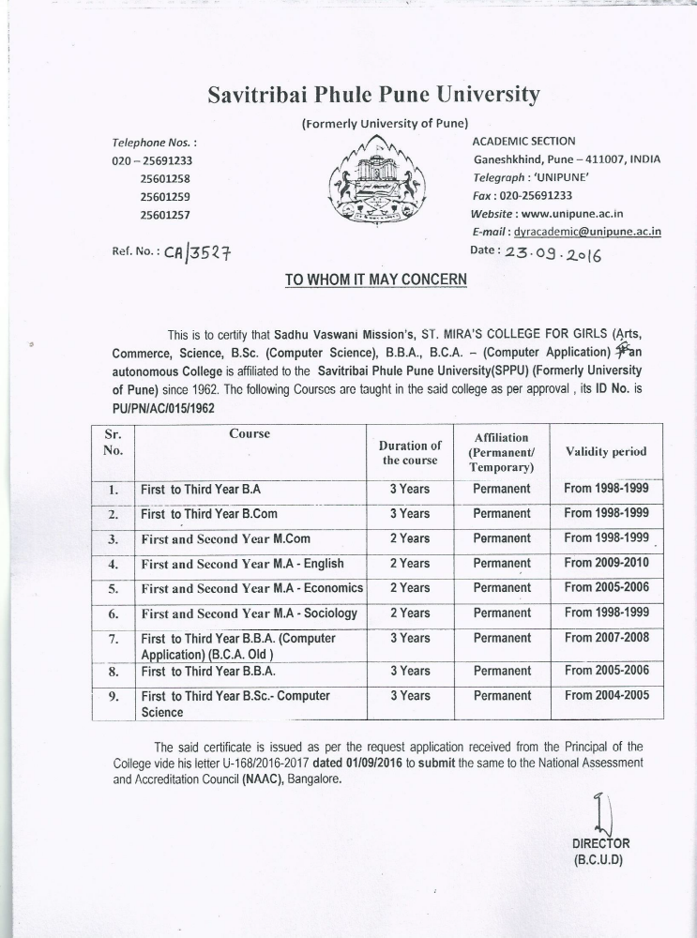

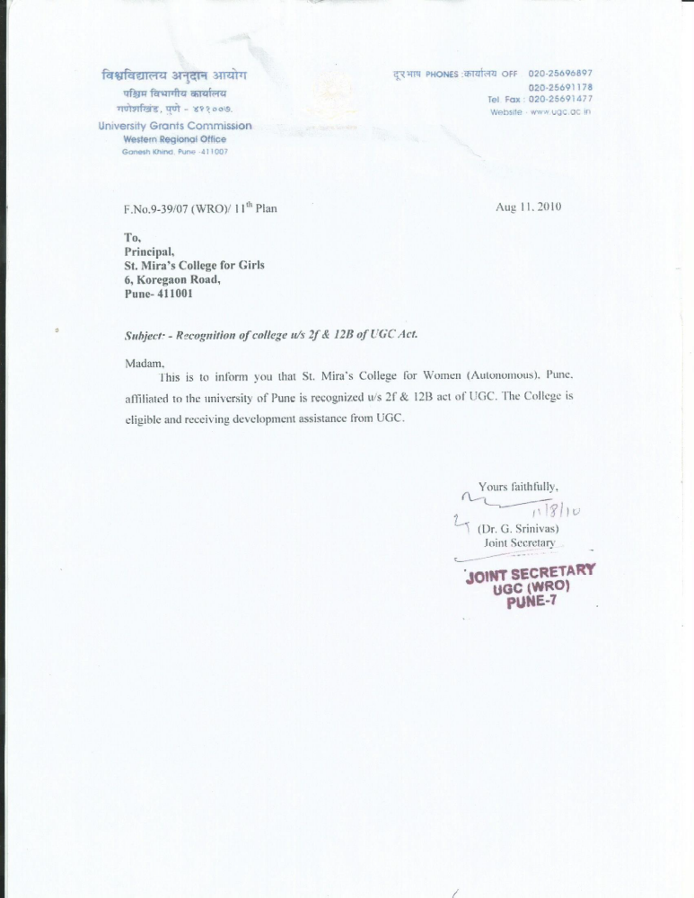

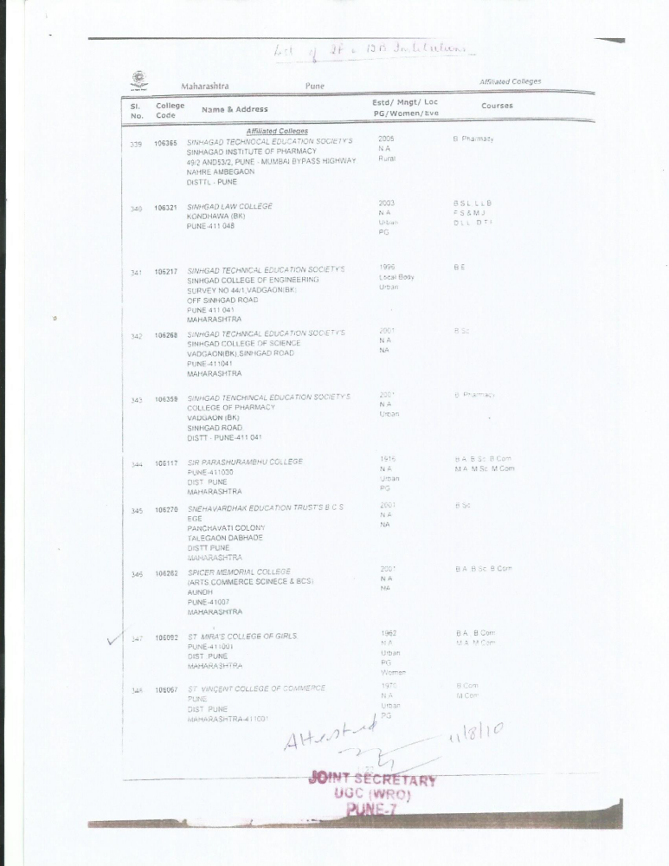

LIST OF DEPARTMENTS
Particulars | UG | PG
ARTS
UG-09 | Economics | Economics
PG- 03 | English | English
 | Sociology | Sociology
 | Psychology
 | Hindi
 | Marathi
 | Education
 | History
 | Politics
COMMERCE | Accounting and Cost Accounting | Business Administration
UG-05 | Business Economics
PG-01 | Business Studies
 | Business Administration(BBA)
 | Business Administration (CA)
SCIENCE | Computer Science | -
UG-01

Sr. No | Name of Subject | Class | Year of Syllabus Revision
 | ARTS
1 | English | FYBA/FYBCOM | 2015
 |  | SYBA/SYBCOM/SYBSc | 2016
 |  | TYBA | 2012 (Due for Rev- 2017)
2 | Hindi | FYBA/FYBCOM | 2015
 |  | SYBA | 2016
 |  | TYBA | 2012 (Due for Rev- 2017)
3 | Marathi | FYBA/FYBCOM | 2015
 |  | SYBA | 2016
 |  | TYBA | 2012 (Due for Rev- 2017)
4 | Politics | FYBA/FYBCOM | 2015
 |  | SYBA | 2016
 |  | TYBA | 2012 (Due for Rev- 2017)
5 | History | FYBA/FYBCOM | 2015
 |  | SYBA | 2016
 |  | TYBA | 2012 (Due for Rev- 2017)
6 | Psychology | FYBA/FYBCOM | 2015
 |  | SYBA | 2016
 |  | TYBA | 2012 (Due for Rev- 2017)
7 | Education | FYBA/FYBCOM | 2015
 |  | SYBA | 2016
 |  | TYBA | 2012 (Due for Rev- 2017)
8 | Sociology | FYBA/FYBCOM | 2015
 |  | SYBA | 2016
 |  | TYBA | 2012 (Due for Rev- 2017)
9 | Economics | FYBA | 2015
 |  | SYBA | 2016
 |  | TYBA | 2012 (Due for Rev- 2017)
10 | A Course in Environmental Studies | All SY Classes | 2016

LIST OF SUBJECTS – SYLLABUS REVISION

Sr. No | Name of Subject | Class | Year of Syllabus Revision
 | COMMERCE
1 | Accountancy | FYBCOM | 2015
 |  | SYBCOM | 2016
 |  | TYBCOM | 2012 (Due for Rev- 2017)
2 | Banking & Finance | FYBA/FYBCOM | 2015
 |  | SYBCOM | 2016
 |  | TYBCOM | 2012 (Due for Rev- 2017)
3 | Business Administration | FYBA/FYBCOM | 2015
 |  | SYBCOM | 2016
 |  | TYBCOM | 2012 (Due for Rev- 2017)
4 | Business Entrepreneurship | FYBA/FYBCOM | 2015
 |  | SYBCOM | 2016
 |  | TYBCOM | 2012 (Due for Rev- 2017)
5 | Marketing | FYBCOM | 2015
 |  | SYBCOM | 2016
 |  | TYBCOM | 2012 (Due for Rev- 2017)
6 | Managerial Economics | FYBCOM | 2015
7 | Business Economics | FYBCOM | 2015
 |  | SYBCOM | 2016
8 | Consumer Protection & Business Ethics | FYBCOM | 2015
9 | Business Mathematics & Statistics | FYBA/FYBCOM | 2015
10 | Advanced I.T. | FYBCOM | 2015
11 | Sindhi | FYBCOM | 2015
12 | Business Management | SYBCOM | 2016
13 | Corporate Law | SYBCOM | 2016
14 | Business Communication | SYBCOM | 2016
15 | Cost & Works Accountancy | SYBCOM | 2016
 |  | TYBCOM | 2012 (Due for Rev- 2017)
16 | Mercantile Law | TYBCOM | 2012 (Due for Rev – 2017)
17 | Auditing & Taxation | TYBCOM | 2012 (Due for Rev – 2017)
18 | International Economics | TYBCOM | 2012 (Due for Rev – 2017)
19 | Indian and Global Economic Development | TYBCOM | 2012 (Due for Rev – 2017)

Sr. No | Name of Subject | Class | Year of Syllabus Revision
 | SCIENCE (COMPUTER SCIENCE)
1 | Algebra and Calculus | FYBSc | 2015
2 | Problem Solving Using Computers and C Programming-1 | FYBSc | 2015
3 | File Organisation and Fundamentals of Databases-1 | FYBSc | 2015
4 | Discrete Mathematics | FYBSc | 2015
5 | Statistical Methods-1 | FYBSc | 2015
6 | Statistical Methods-2 | FYBSc | 2015
7 | Principles of Analog Electronics | FYBSc | 2015
8 | Principles of Digital Electronics | FYBSc | 2015
9 | Problem Solving Using Computers and C programming-II | FYBSc | 2015
10 | FIle Organization and Fundamentals of Databases-II | FYBSc | 2015
11 | Graph Theory | FYBSc | 2015
12 | Linear Algebra | FYBSc | 2015
13 | Satatistical Methods -I | FYBSc | 2015
14 | Statistical Methods -II | FYBSc | 2015
16 | Principles of Analog Electronics II | FYBSc | 2015
17 | Principles of Digital Electronics II | FYBSc | 2015
18 | Computer Science Practical Paper-I | FYBSc | 2015
19 | Computer Science Practical Paper-II | FYBSc | 2015
20 | Mathematics Practical | FYBSc | 2015
21 | Statistics Practical | FYBSc | 2015
22 | Electronics Practical | FYBSc | 2015

Sr. No | Name of Subject | Class | Year of Syllabus Revision
 | SCIENCE (COMPUTER SCIENCE)
23 | Computer Science Paper-1 | SYBSc | 2016
24 | Computer Science Paper-2 | SYBSc | 2016
25 | Mathematics Paper-1 | SYBSc | 2016
26 | Mathematics Paper-2 | SYBSc | 2016
27 | Electronics Paper-1 | SYBSc | 2016
28 | Electronics Paper-2 | SYBSc | 2016
29 | Computer Science Lab Course-1 | SYBSc | 2016
30 | Computer Science Lab Course-2 | SYBSc | 2016
31 | Mathematics Practical | SYBSc | 2016
32 | Electronics Practical | SYBSc | 2016
33 | System Programming | TYBSc | Due for Revision- 2017
34 | Theoretical Computer Science | TYBSc | Due for Revision- 2017
35 | Computer Networks-1 | TYBSc | Due for Revision- 2017
36 | Internet Programming-1 | TYBSc | Due for Revision- 2017
37 | Programming in Java-1 | TYBSc | Due for Revision- 2017
38 | Object Oriented S/W Engg | TYBSc | Due for Revision- 2017
39 | System Programming and Operating System | TYBSc | Due for Revision- 2017
40 | Compiler Constructions-2 | TYBSc | Due for Revision- 2017
41 | Computer Networks-2 | TYBSc | Due for Revision- 2017
42 | Internet Programming -2 | TYBSc | Due for Revision- 2017
43 | Programming in Java-2 | TYBSc | Due for Revision- 2017
44 | Computer Graphics | TYBSc | Due for Revision- 2017
45 | Lab course-1 | TYBSc | Due for Revision- 2017
46 | Lab course-2 | TYBSc | Due for Revision- 2017
47 | Lab course-3 | TYBSc | Due for Revision- 2017

Sr. No | Name of Subject | Class | Year of Syllabus Revision
 | Bachelor of Business Administration
1 | Business Organisation & System | FYBBA | 2015
2 | Business Communication Skills | FYBBA | 2015
3 | Business Accounting | FYBBA | 2015
4 | Business Economics (Micro) | FYBBA | 2015
5 | Business Mathematics | FYBBA | 2015
6 | Business Demography & Environmental Studies | FYBBA | 2015
7 | Principles of Management | FYBBA | 2015
8 | Principles of Marketing | FYBBA | 2015
9 | Principles of Finance | FYBBA | 2015
10 | Basics of Cost Accounting | FYBBA | 2015
11 | Business Statistics | FYBBA | 2015
12 | Business Informatics | FYBBA | 2015
13 | Personality Development | SYBBA | 2016
14 | Business Ethics | SYBBA | 2016
15 | Human Resource Management | SYBBA | 2016
16 | Management Accounting | SYBBA | 2016
17 | Business Economics (Macro) | SYBBA | 2016
18 | IT in Management | SYBBA | 2016
19 | Production & Operations Management | SYBBA | 2016
20 | Industrial Relations & Labour Law | SYBBA | 2016
21 | Business Taxation | SYBBA | 2016
22 | International Business | SYBBA | 2016
23 | Management Information System | SYBBA | 2016
24 | Business Exposure | SYBBA | 2016
25 | Supply Chain & Logistics Management | TYBBA | 2017
26 | Entrepreneurship Development | TYBBA | 2017
27 | Business Law | TYBBA | 2017
28 | Research Methodology ( Tools & Analysis) | TYBBA | 2017
29 | (Finance) - Analysis of Financial Statements | TYBBA | 2017

Sr. No | Name of Subject | Class | Year of Syllabus Revision
30 | (Marketing) - Sales Management | TYBBA | 2017
31 | (HRM)- Human Resource Management Principles & Functions | TYBBA | 2017
32 | (Finance) - long term finance (only if opted for ‘analysis of financial statements-505-a) | TYBBA | 2017
33 | (Marketing) -Retail Management (only if opted for ‘sales management’-505-b) | TYBBA | 2017
34 | (HRM)- Human Resource Practices (only if opted for ‘human resource management principles & functions-505-c) | TYBBA | 2017
35 | Business Planning & Project Management | TYBBA | 2017
36 | Event Management | TYBBA | 2017
37 | Management Control System | TYBBA | 2017
38 | E-commerce | TYBBA | 2017
39 | (Finance) - Financial services (only if opted for ‘analysis of financial statements-505-a) | TYBBA | 2017
40 | (Marketing) - Advertising & Sales promotion (only if opted for ‘sales management’-505-b) | TYBBA | 2017
41 | (HRM)- labour laws (only if opted for ‘human resource management principles & functions-505-c) | TYBBA | 2017
42 | (Finance) projects/ cases in finance (only if opted for ‘analysis of financial statements-505-a) | TYBBA | 2017
43 | (Marketing) - projects/ cases in marketing (only if opted for ‘sales management’-505-b) | TYBBA | 2017
44 | (HRM)- projects/ cases in HRM (only if opted for ‘human resource management principles & functions-505-c) | TYBBA | 2017

Sr. No | Name of Subject | Class | Year of Syllabus Revision
 | Bachelor of Business Administration (BCA)
1 | Modern Operating Environment & Operating System | FYBCA | 2015
2 | Financial Accounting | FYBCA | 2015
3 | Principles of Programming & Algorithms & Introduction to C language | FYBCA | 2015
4 | Business Communication | FYBCA | 2015
5 | Principles of Management | FYBCA | 2015
6 | Laboratory Course – I (Based on. Paper no.BC11501 & BC11503) | FYBCA | 2015
7 | Procedure Oriented Programming using C | FYBCA | 2015
8 | File Organization & Data Base Management System | FYBCA | 2015
9 | Organizational Behavior | FYBCA | 2015
10 | Computer Applications in Statistics | FYBCA | 2015
11 | E-Commerce Concepts | FYBCA | 2015
12 | Laboratory Course – II(Based on. Paper no.BC21501 & BC21503) | FYBCA | 2015
13 | RDBMS (Relational Database Management System) | SYBCA | 2016
14 | Data Structure Using C | SYBCA | 2016
15 | Introduction to Operating Systems | SYBCA | 2016
16 | Mathematics & Statistics | SYBCA | 2016
17 | Software Engineering | SYBCA | 2016
18 | Laboratory Course – III (Based on. Paper no. BC31601 & BC31602) | SYBCA | 2016
19 | Object Oriented Programming Using C++ | SYBCA | 2016
20 | Programming in Visual Basic | SYBCA | 2016
21 | Computer Networking | SYBCA | 2016
22 | Enterprise Resource Planning and Management | SYBCA | 2016
23 | Human Resource Management | SYBCA | 2016
24 | Laboratory Course – IV(Based on. Paper no. BC41601 & BC41602) | SYBCA | 2016

25 | Java Programming | TYBCA | 2017
26 | Web Technologies | TYBCA | 2017
27 | Dot Net Programming | TYBCA | 2017
28 | Object Oriented Software Engg. | TYBCA | 2017
29 | Software Project – I [ C++ / VB Technology] | TYBCA | 2017
30 | Laboratory Course – V [Based on Paper No. 501 & 502 | TYBCA | 2017
31 | Advanced Web Technologies | TYBCA | 2017
32 | Advanced Java | TYBCA | 2017
33 | Recent Trends in IT | TYBCA | 2017
34 | Software Testing | TYBCA | 2017
35 | Software Project – II [Java / Dot net Technology] | TYBCA | 2017
36 | Laboratory Course – VI[Based on Paper No. 601 & 602 | TYBCA | 2017

Sr. No | Name of Subject | Class | Year of Syllabus Revision
 | MA Sociology Semester I
1 | Classical Sociological Tradition | MA PART I | 2015
2 | Sociology in India | MA PART I | 2015
3 | Sociology of Media | MA PART I | 2015
4 | Socio of Maharashtra: Culture& Society | MA PART I | 2015
 | MA Sociology Semester II
5 | Methodology of Social Research | MA PART I | 2015
6 | Sociology of Education | MA PART I | 2015
7 | Sociology of Labour | MA PART I | 2015
8 | Introduction to Sociological Theories | MA PART I | 2015
 | MA English Semester I
9 | English Literature from 1550-1798 | MA PART I | 2015
10 | English Literature from 1798- 2000 | MA PART I | 2015
11 | Linguistics and Contemporary English | MA PART I | 2015
12 | Literary Criticism and Theory | MA PART I | 2015
 | MA English Semester II
13 | English Literature from 1550-1798 | MA PART I | 2015
14 | English Literature from 1798-2000 | MA PART I | 2015
15 | Linguistics and Contemporary English | MA PART I | 2015
16 | Literary Criticism and Theory | MA PART I | 2015
 | MA Economics Semester I
17 | Micro Economic Analysis - I | MA PART I | 2015
18 | Public Economics - I | MA PART I | 2015
19 | International Trade | MA PART I | 2015
20 | Indian Economic Policy | MA PART I | 2015

 | MA Economics Semester II
21 | Micro Economic Analysis - II | MA PART I | 2015
22 | Public Economics – II | MA PART I | 2015
23 | International Finance | MA PART I | 2015
24 | Industrial Economics | MA PART I | 2015
 | Mcom Semester I
25 | Management Accounting | MCOM PART I | 2015
26 | Strategic Management | MCOM PART I | 2015
27 | Production & Operation Management | MCOM PART I | 2015
28 | Financial Management | MCOM PART I | 2015
 | Mcom Semester II
29 | Financial Analysis and Control | MCOM PART I | 2015
30 | Industrial Economics | MCOM PART I | 2015
31 | Business Ethics & Professional Values | MCOM PART I | 2015
32 | Elements of Knowledge Management | MCOM PART I | 2015

Sr. No | Name of Subject | Class | Year of Syllabus Revision
 | MA Sociology Semester III
1 | Introduction to Development Studies | MA PART II | 2016
2 | Research Application Skills | MA PART II | 2016
3 | Introduction to Cultural Studies | MA PART II | 2016
4 | Sociology of Gender | MA PART II | 2016
 | MA Sociology Semester IV | MA PART II | 2016
5 | Sociology of Globalization | MA PART II | 2016
6 | Contemporary Social Theories | MA PART II | 2016
7 | Sociology of Art | MA PART II | 2016
8 | Ethnicity in India | MA PART II | 2016
 | MA English Semester III | MA PART II | 2016
9 | Indian Writing in English | MA PART II | 2016
10 | British Poetry | MA PART II | 2016
11 | World Drama | MA PART II | 2016
12 | American Literature | MA PART II | 2016
 | MA English Semester IV | MA PART II | 2016
13 | Indian Writing in English | MA PART II | 2016
14 | International Voices | MA PART II | 2016
15 | World Drama | MA PART II | 2016
16 | American Literature | MA PART II | 2016
 | MA Economics Semester III | MA PART II | 2016
17 | Macro Ecconomics - I | MA PART II | 2016
18 | Growth and Development – I | MA PART II | 2016
19 | Research Methodology | MA PART II | 2016
20 | Rural Development | MA PART II | 2016

Sr. No | Name of Subject | Class | Year of Syllabus Revision
 | MA Economics Semester IV
21 | Macro Economics - II | MA PART II | 2016
22 | Growth and Development - II | MA PART II | 2016
23 | Contemporary Issues in Economics | MA PART II | 2016
24 | Urban Development | MA PART II | 2016
 | Mcom Semester III
25 | Business Finance | MCOM PART II | 2016
26 | Research Methodology for Business | MCOM PART II | 2016
27 | Human Resource Management | MCOM PART II | 2016
28 | Behavioral Finance | MCOM PART II | 2016
 | Mcom Semester IV
29 | Capital Markets and Financial Services | MCOM PART II | 2016
30 | Industrial Economic Environment | MCOM PART II | 2016
31 | Recent Advances in Business Administration | MCOM PART II | 2016
32 | Project Work | MCOM PART II | 2016

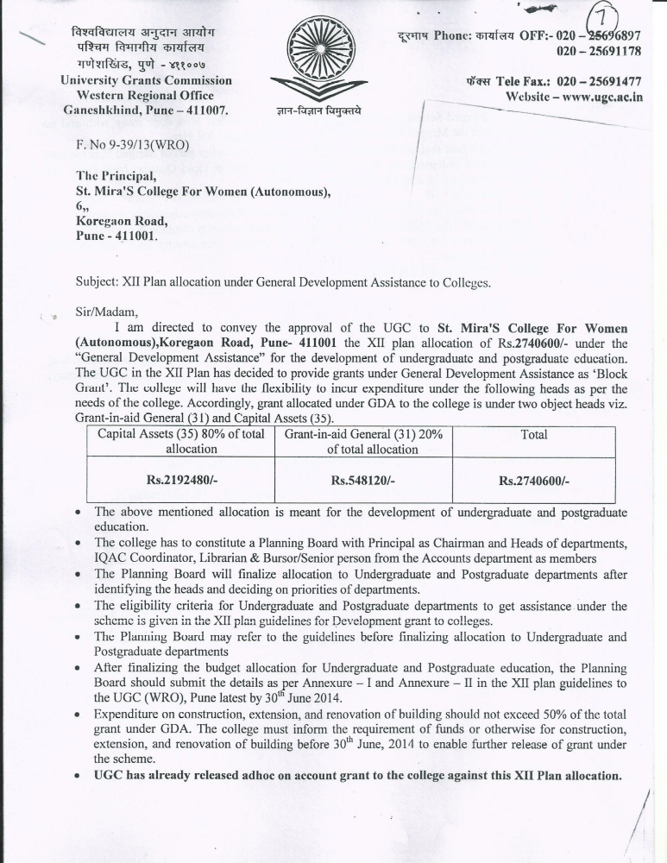

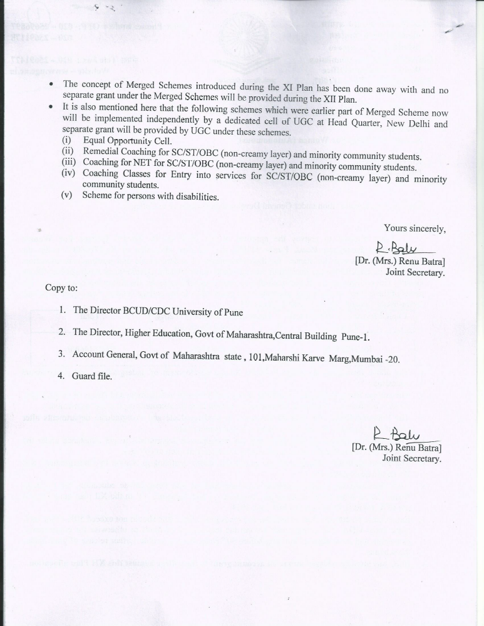

Statement showing details of Orientation Course
2012-13
Sr.No |  | Name of the Faculty |  | Orientation Course at |  |  | Date
1 |  | Hasina Shaikh |  | Orientation course for Programme Officers of the NSS held at the NSS Empanelled Training Institute Ahmednagar College |  |  | 8.10.2012 to 13.10.2012
2 |  | Manisha Pimpalkhare |  | Conducted at the UGC Academic Staff College, University of Pune under the UGC scheme |  |  | 3.12.12 to 30.12.12
3 |  | Rajni Singh |  | UGC Sponsored Orientation Programme organized by the the Academic Staff College, University of Pune |  |  | 2.1.13 to 30.1.13
4 |  | Purnima Kulkarni |  | UGC Sponsored Orientation Programme organized by the the Academic Staff College, University of Pune |  |  | 1.3.13 to 28.3.13
5 |  | Sangeeta Deshmukh |  | UGC Sponsored Orientation Programme organized by the the Academic Staff College, University of Pune |  |  | 1.3.13 to 28.3.13
2013-14
Sr.No |  | Name of the Faculty |  | Orientation Course at |  |  | Date
1 |  | Sangeeta Deshmukh |  | NSS Orientation Course for Programme officers of the NSS held at the NSS Empanelled Training Institute Ahmednagar College, Ahmednagar |  |  | 25.11.13 to 1.12.13
2 |  | Shaikh Hasina |  | UGC Sponsored Orientation Programme organized by the the Academic Staff College, University of Pune |  |  | 13.2.14 to 12.3.14
3 |  | Meenal Sumant |  | UGC Sponsored Orientation Programme organized by the the Academic Staff College, University of Pune |  |  | 13.2.14 to 12.3.14
2014-2015
Sr.No |  | Name of the Faculty |  | Orientation Course at |  |  | Date
1 |  | Shanti Fernandes |  | UGC Sponsored Orientation Programme organized by the Academic Staff College, University of Pune |  |  | 1.8.14 to 28.8.14
2 |  | Snober Satarwala |  | UGC Sponsored Orientation Programme organized by the Academic Staff College, University of Pune |  |  | 1.8.14 to 28.8.14
Statement showing details of Refresher Course
2012-13
Sr. No | Name of the Faculty |  | Refresher course at |  | Date
1 | Snober Satarwala |  | UGC Sponscored Regresher Programme organized by the Department of English, University of Pune under the auspices of Academic Staff College, University of Pune, Pune |  | 3.1.2013 to 23.1.2013
2 | Vaishali Diwakar |  | UGC sponsored Regresher Programme organized by the Bharatratna Dr.Babasahed Ambedkar Chair and Studies Centre,University of Pune under the auspices of Academic Staff College, Univ of Pune |  | 5.1.13 to 25.1.13
3 | Jaya Rajgopalan |  | UGC sponsored Regresher Programme organized by the Bharatratna Dr.Babasahed Ambedkar Chair and Studies Centre,University of Pune under the auspices of Academic Staff College, Univ of Pune |  | 5.1.13 to 25.1.13
4 | Sadhana Kulkarni |  | UGC Sponsored Refresher Programme organized by the Annabhau Sathe Adhyasan, University of Pune under the auspices of Academic staff College, University of Pune |  | 10.9.2012 to 30.9.12
2013-14
Sr. No | Name of the Faculty |  | Refresher course at |  | Date
1 | Jyoti Chintan |  | Refresher Course conducted at the Deccan Education Society's Brihan Maharashtra College of Commerce, Pune under the UGC Scheme |  | 16.9.13 to 6.10.13
2 | Meenakshi Balkawade |  | Refresher Course conducted at the Deccan Education Society's Brihan Maharashtra College of Commerce, Pune under the UGC Scheme |  | 16.9.13 to 6.10.13
3 | Ujjwala Deshpande |  | UGC Sponsored Refresher Course oganized by Nodal Centre of Excellence for Human Rights Education,School of Law, Rights & Constitutional Goverence, Tata Institute of Social Sciences,Deonar Mumbai |  | 9.12.13 to 30.12.13
2014-2015
Sr. No | Name of the Faculty |  | Refresher course at |  | Date
1 | Manisha Pimpalkhare |  | UGC Sponsored Refresher Programme organized by the Women's Studies Center, ILS Law College Pune in Collaboration with the Academic Staff College, Savitribai Phule Pune University, Pune |  | 17.9.14 to 7.10.14
2 | Meenal Sumant |  | UGC Sponsored Refresher Programme organized by Chandmal Tarachand Bora Arts, Commrece and Science College, Shirur Dist Pune under auspices of Academic Staff College, Savitribai Phule Pune University, Pune |  | 27.10.14 to 16.11.14
3 | Dimple Buche |  | UGC Sponsored Refresher Programme organized by Chandmal Tarachand Bora Arts, Commrece and Science College, Shirur Dist Pune under auspices of Academic Staff College, Savitribai Phule Pune University, Pune |  | 27.10.14 to 16.11.14
4 | Rajni Singh |  | UGC Sponsored Refresher Programme organized by Chandmal Tarachand Bora Arts, Commrece and Science College, Shirur Dist Pune under auspices of Academic Staff College, Savitribai Phule Pune University, Pune |  | 27.10.14 to 16.11.14
5 | Elizabeth Kanade |  | UGC Sponsored Refresher Programme organized by Chandmal Tarachand Bora Arts, Commrece and Science College, Shirur Dist Pune under auspices of Academic Staff College, Savitribai Phule Pune University, Pune |  | 27.10.14 to 16.11.14
2015-2016
Sr. No | Name of the Faculty |  | Refresher course at |  | Date
1 | Purnima Kulkarni |  | SPPU UGC Scheme of ICT Refresher Courses Conducted at K.R.T.Arts, B.H.Commerce & A.M.Science College (KTHM College) Gangpur Road, Nashik |  | 6.5.15 to 26.5.15
2 | Minakshi Balkawade |  | UGC Sponsored Refresher Programme organized by the Department of Commerce, Savitribai Phule Pune University |  | 1.10.15 to 21.10.15
3 | Shanti Fernandes |  | UGC Sponsored Refresher Programme organized by the Department of Commerce, Savitribai Phule Pune University |  | 1.10.15 to 21.10.15
4 | Hasina Shaikh |  | UGC Sponsored Refresher Course oganized at the Department of Education & Extension, Savitribai Phule Pune University |  | 12.10.15 to 1.11.15

LIST OF THE MINOR AND MAJOR RESEARCH PROJECT

Sl.NO. | YEAR | NAME OF THE TEACHER | NAME OF THE PROJECT | TOTAL GRANT | AMOUNT RECEIVED
1 | 1.6.2014 | Dr. Mrs. Rama Venkatachalam | Indian Council of Social Science Research (ICSSR) | 4,00,000 | 1,60,000



